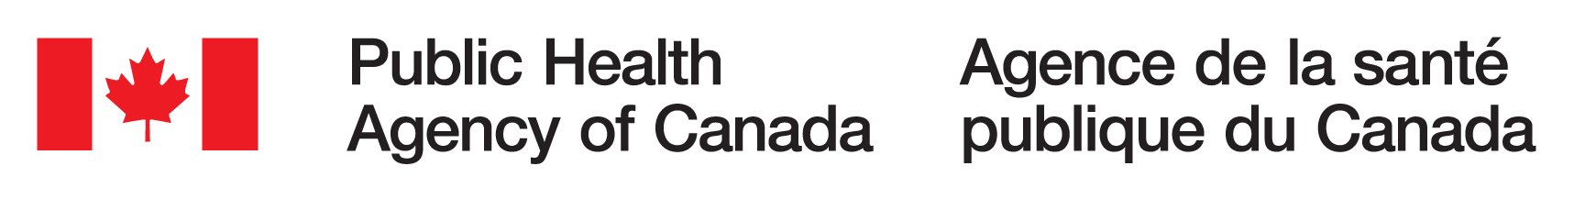

Canadian Do-It-Yourself Biology Summit
January 22, 2020 100 Colonnade Rd., Ottawa, Ontario (Media Room)

VIRTUAL ACCESS TO THE EVENT:

https://gts-ee.webex.com/webappng/sites/gts-ee/meeting/info/1144bc57660846349f15cf6e80a6a35f
AUDIO CONNECTION:
Toll Free (Canada/US): 877-413-4814 Local and International: 613-960-7526 Conference ID: 9382625

AGENDA
8:00 – 8:30 Arrival and Registration

8:30 - 9:00 Welcome Remarks
Kimby Barton Centre for Biosecurity, PHAC
Pascal Michel Office of the Chief Science Officer, PHAC

9:00 – 10:45 Panel Discussion: The Future of DIY Biology in Canada
David Lloyd FREDsense, Calgary
Simon Monis Biotown, Ottawa
Scott Pownall DYI Bio Vancouver
Adrian Philip Ottawa Bio Science
Derek Jacoby Makerspace Victoria

10:30 - 10:45 Health Break

10:45 – 12:00 Panel Discussion: The International DIY Biology Movement
Angela Armendariz Genspace, New York City
Janis Schleusner iGEM Foundation
Thomas Landrain Just One Giant Lab, Paris

12:00 - 13:00 Lunch

13:00 - 14:15 Panel Discussion: Challenges and Opportunities in DYI Biology Safety
Laura Keffer-Wilkes SynBridge, Lethbridge
Kevin Chen Bricobio, Montreal
Marianne Heisz Centre for Biosecurity, PHAC

14:15 - 14:30 Closing Remarks
Kimby Barton Director General, Centre for Biosecurity, PHAC

14:30 - 14:45 Health Break

14:45 – 16:00 DIY Bio Fair

